Open-RMF Map Editor
download RMF Traffic Editor
for-> humble apt
sudo apt update
sudo apt install ros-humble-rmf-traffic-editor
source /opt/ros/humble/setup.bash
traffic-editor

for functions
sudo apt update
sudo apt install -y git
mkdir -p ~/rmf_source
cd ~/rmf_source
git clone -b humble https://github.com/open-rmf/rmf_traffic_editor.git
for-> build from source
link-> https://github.com/open-rmf/rmf_traffic_editor?utm_source=chatgpt.com
mkdir -p ~/traffic_editor_ws/src
cd ~/traffic_editor_ws/src

git clone -b humble \
https://github.com/open-rmf/rmf_traffic_editor.git

cd ~/traffic_editor_ws

source /opt/ros/humble/setup.bash

sudo apt install python3-colcon-common-extensions python3-rosdep

rosdep install \
--from-paths src \
--ignore-src \
--rosdistro humble \
-r -y

colcon build
source install/setup.bash

traffic-editor

After opening traffic editor
1) create a copy of pgm file created with slam and change the extension to png
2)In editor click building -> new-> then create level by clicking add
3)In the dialog give name and add the png created
4)click the add measurement in the editor (pink line)
5)click one cornor to another cornor following a strating line then change to select (arrow)
6)click the line and its properties will show and change the distance matching the actual distance of the world
7)how to get distance value-> get the resolution value from the yaml file eg:0.05 (5cm)
8)get the image dimension ->go to the folder having the map and print this python code
python3 -c "from PIL import Image; im=Image.open('office_map.pgm'); print(im.size)"
eg: (404 ,396) w-404, h-398
9)distance value calculation
w- 404X0.05=20.2
h-396X0.05=19.8
diagonal distance =root of(w^2+h^2)
10) after adding distance save it using building -> save and close the editor.

Now set the walls. this will be used for creation of automatically generated simulation environment.
use the blue line (wall) and the obstacle are columns we can also create walls for it. we can also change the texture of walls and columns by using the ones provided in the official github repository for the editor.
the thickness, height of the wall can be changed in the wall.py

add floor using add floor button and click all the vertices of the walls and save them using right click.

add lanes using add lane button and dram the way your robot needs to move

click the small circle inside hte lane and give properties like charing station and we can add property by clicking add property below the properties window. change the value of that to true

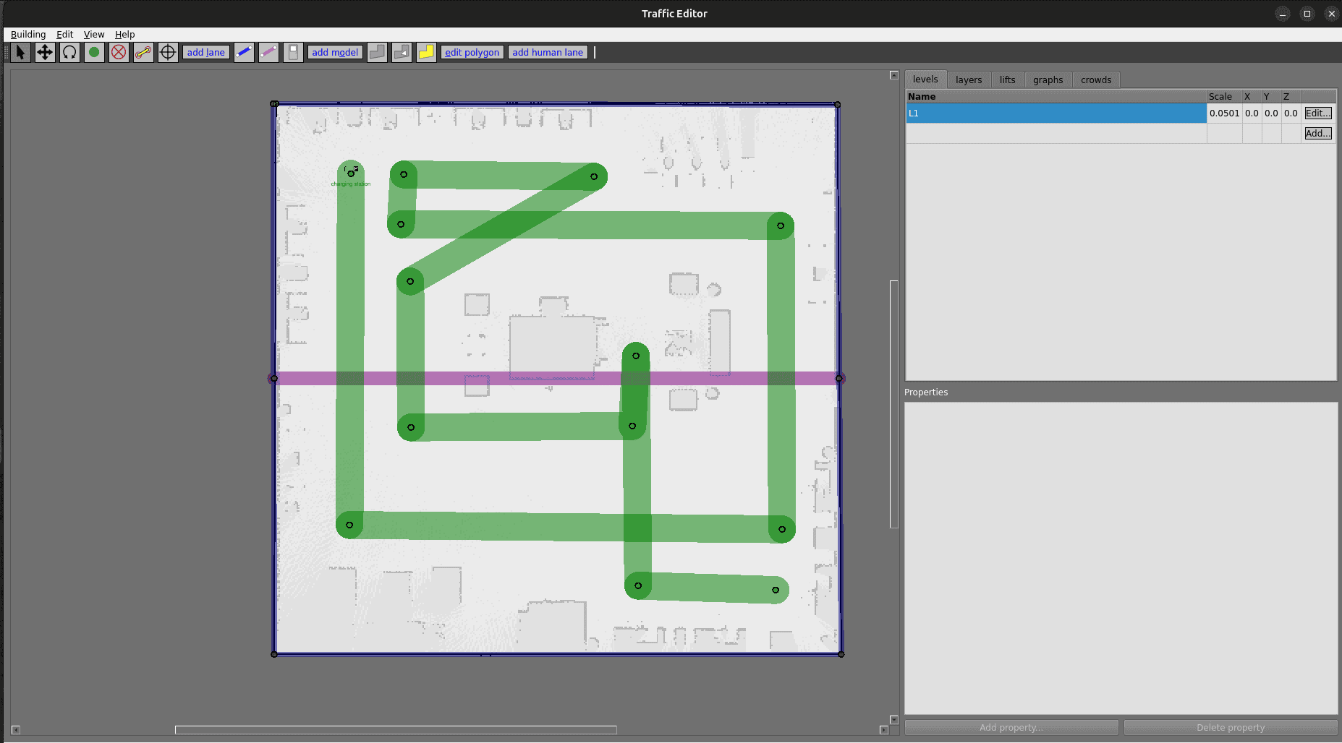

for bringing this world into gazebo
install the required dependencies
sudo apt-get update

sudo apt-get install -y \
python3-colcon-common-extensions \
python3-shapely \
python3-yaml \
python3-requests

Create a workspace
mkdir -p ~/rmf_traffic_editor_ws/src

ln -s ~/rmf_source/rmf_traffic_editor \
~/rmf_traffic_editor_ws/src/rmf_traffic_editor

ls ~/rmf_traffic_editor_ws/src/rmf_traffic_editor

Build the packages
source /opt/ros/humble/setup.bash

cd ~/rmf_traffic_editor_ws

colcon build --packages-up-to rmf_building_map_tools

Source the built workspace
source ~/rmf_traffic_editor_ws/install/setup.bash
ros2 pkg executables rmf_building_map_tools

Generate your Gazebo world
ros2 run rmf_building_map_tools building_map_generator gazebo \
/path/to/your/building.building.yaml \
/path/to/output/hospital.world \
/path/to/output/models

Install Fiona
sudo apt-get update
sudo apt-get install -y python3-fiona

python3 -c "import fiona; print('Fiona version:', fiona.__version__)"
version should be printed
source /opt/ros/humble/setup.bash
source ~/rmf_traffic_editor_ws/install/setup.bash
find ~ -type f \( -name "*.building.yaml" -o -name "*.building.yml" \)
find ~/rmf_source/rmf_traffic_editor/rmf_traffic_editor_test_maps \
-type f -name "*.yaml"
mkdir -p ~/hospital_map/output/models

ros2 run rmf_building_map_tools building_map_generator gazebo \
/actual/path/to/your.building.yaml \
~/hospital_map/output/hospital.world \
~/hospital_map/output/models

sudo apt-get update
sudo apt-get install -y python3-pyproj
python3 -c "import pyproj; print('pyproj version:', pyproj.__version__)"

source /opt/ros/humble/setup.bash
source ~/rmf_traffic_editor_ws/install/setup.bash

mkdir -p ~/hospital_map/output/models

ros2 run rmf_building_map_tools building_map_generator gazebo \
~/workspace/src/backend_ros/src/AMR_Fleet_Monitoring/config/office_RMF_Editor2.building.yaml \
~/hospital_map/output/hospital.world \
~/hospital_map/output/models

sudo apt-get update
sudo apt-get install -y python3-rtree

python3 -c "import rtree; print('rtree installed successfully')"

source /opt/ros/humble/setup.bash
source ~/rmf_traffic_editor_ws/install/setup.bash

ros2 run rmf_building_map_tools building_map_generator gazebo \
~/workspace/src/backend_ros/src/AMR_Fleet_Monitoring/config/office_RMF_Editor2.building.yaml \
~/hospital_map/output/hospital.world \
~/hospital_map/output/models

ls -lh ~/hospital_map/output/hospital.world
gazebo ~/hospital_map/output/hospital.world

